Hybrid Intelligent System for Student Performance Prediction
Name: Pranav Upadhyay
Registration No: 23FE10CSE00538

1. Introduction
This project develops a hybrid intelligent system combining fuzzy logic and neural networks to predict student performance. The system uses ANFIS (Adaptive Neuro-Fuzzy Inference System), which integrates human-like reasoning with machine learning.

2. Inputs and Output
Inputs:
- Attendance (0–100)
- Assignment Marks (0–100)
- Test Marks (0–100)
Output:
- Performance Level:
  - Poor (1)
  - Average (2)
  - Good (3)

3. Methodology
The system uses ANFIS, which combines:
- Fuzzy logic for rule-based reasoning
- Neural network for learning from data

4. Dataset
Sample dataset used:
Attendance | Assignment | Test | Performance
80 | 75 | 70 | 3
60 | 65 | 60 | 2
40 | 50 | 45 | 1
90 | 85 | 88 | 3
30 | 40 | 35 | 1
70 | 72 | 68 | 2

5. Implementation
The system is implemented in MATLAB using ANFIS.
- genfis1() creates initial fuzzy system
- anfis() trains the system

6. Integration of Fuzzy Logic and Neural Network
- Fuzzy logic defines rules and membership functions
- Neural network adjusts parameters using training data
- This improves prediction accuracy over time

7. Results
The training error decreases over iterations, showing that the model is learning effectively.
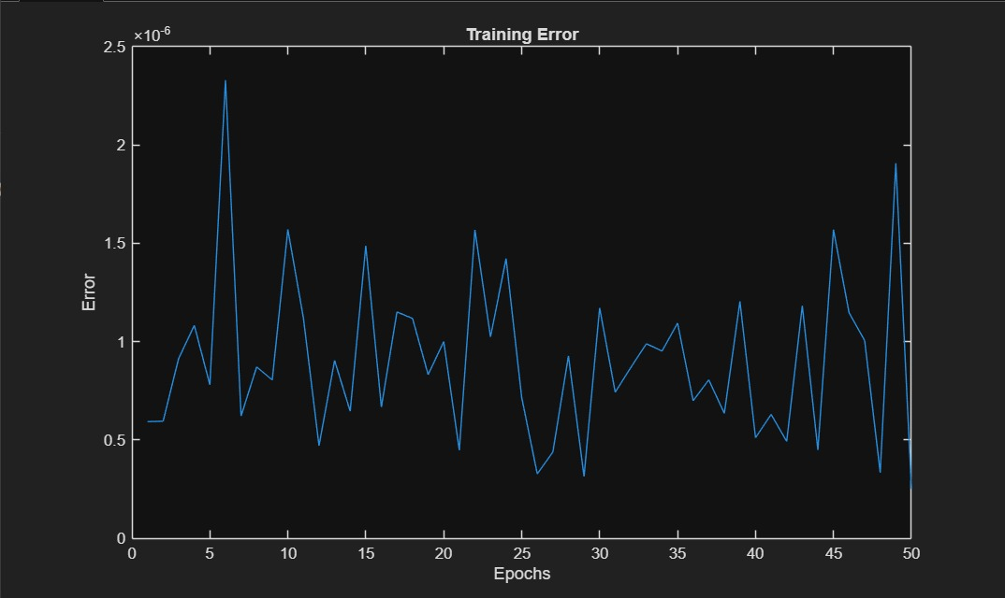

8. Conclusion
The hybrid system successfully predicts student performance using both fuzzy reasoning and machine learning. ANFIS provides better adaptability compared to standalone fuzzy systems.

9. References
- MATLAB ANFIS Documentation
- Lecture Notes on Hybrid Intelligent Systems

